Practical no 1

## **Create Android Application**

The first step is to create a simple Android Application using Android studio. When you click on Android studio icon, it will show screen as shown below

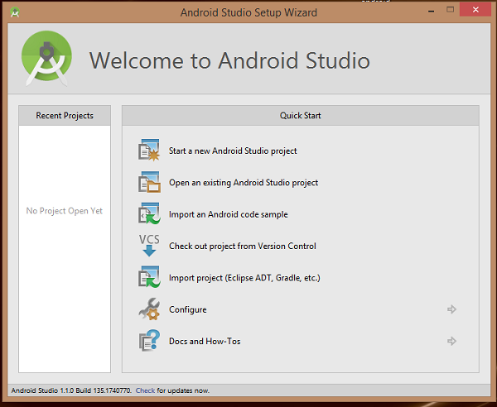

You can start your application development by calling start a new android studio project. in a new installation frame should ask Application name, package information and location of the project.−

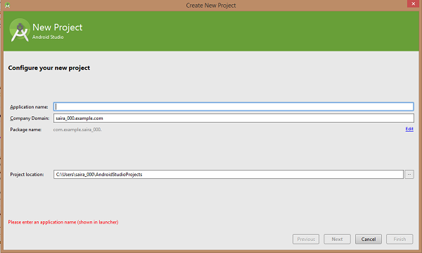

After entered application name, it going to be called select the form factors your application runs on, here need to specify Minimum SDK, in our tutorial, I have declared as API23: Android 6.0(Mashmallow) −

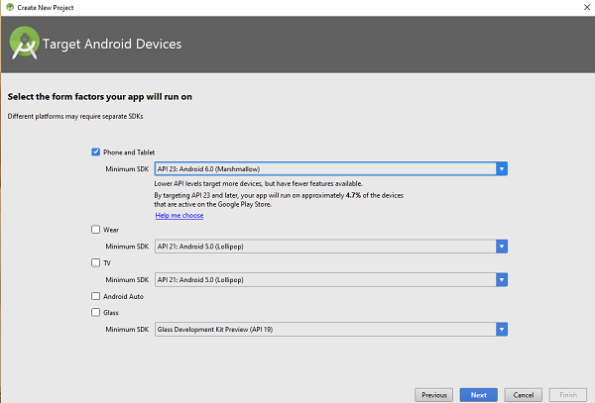

The next level of installation should contain selecting the activity to mobile, it specifies the default layout for Applications.

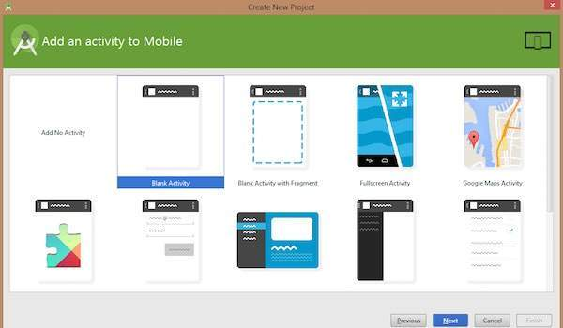

At the final stage it going to be open development tool to write the application code.

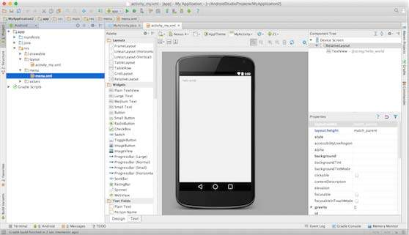

Practical no 2 : Button and toggle button

<?xml version="1.0" encoding="utf-8"?>

<androidx.constraintlayout.widget.ConstraintLayout

xmlns:android="http://schemas.android.com/apk/res/android"

xmlns:app="http://schemas.android.com/apk/res-auto"

xmlns:tools="http://schemas.android.com/tools"

android:layout_width="match_parent"

android:layout_height="match_parent"

android:background="#168BC34A"

tools:context=".MainActivity">

<!-- Button added in the activity -->

<Button

android:id="@+id/button"

android:layout_width="wrap_content"

android:layout_height="wrap_content"

android:background="#4CAF50"

android:paddingStart="10dp"

android:paddingEnd="10dp"

android:text="@string/btn"

android:textColor="@android:color/background_light"

android:textSize="24sp"

app:layout_constraintBottom_toBottomOf="parent"

app:layout_constraintEnd_toEndOf="parent"

app:layout_constraintStart_toStartOf="parent"

app:layout_constraintTop_toTopOf="parent" />

</androidx.constraintlayout.widget.ConstraintLayout>

import androidx.appcompat.app.AppCompatActivity;

import android.content.Context;

import android.os.Bundle;

import android.view.View;

import android.widget.Button;

import android.widget.Toast;

public class MainActivity extends AppCompatActivity {

@Override

protected void onCreate( Bundle savedInstanceState ) {

super.onCreate(savedInstanceState);

setContentView(R.layout.activity_main);

// storing ID of the button

// in a variable

Button button = (Button)findViewById(R.id.button);

// operations to be performed

// when user tap on the button

if (button != null) {

button.setOnClickListener((View.OnClickListener)(new View.OnClickListener() {

public final void onClick(View it) {

// displaying a toast message

Toast.makeText((Context)MainActivity.this, R.string.message, Toast.LENGTH_LONG).show();

}

}));

}

}

}

Toggle Button :

<RelativeLayout

xmlns:android="http://schemas.android.com/apk/res/android"

xmlns:app="http://schemas.android.com/apk/res-auto"

xmlns:tools="http://schemas.android.com/tools"

android:layout_width="match_parent"

android:layout_height="match_parent"

android:padding="16dp"

android:background="@color/white"

tools:context=".MainActivity">

<ToggleButton

android:id="@+id/toggleButton"

android:layout_width="wrap_content"

android:layout_height="wrap_content"

android:layout_centerHorizontal="true"

android:layout_centerVertical="true"

android:onClick="onToggleClick"

/>

<TextView

android:id="@+id/textView"

android:layout_width="wrap_content"

android:layout_height="wrap_content"

android:layout_marginBottom="100dp"

android:layout_centerVertical="true"

android:layout_centerHorizontal="true"

android:layout_above="@+id/toggleButton"

android:textStyle="bold"

android:textColor="@color/black"/>

</RelativeLayout>

import androidx.appcompat.app.AppCompatActivity;

import android.os.Bundle;

import android.view.View;

import android.widget.TextView;

import android.widget.ToggleButton;

public class MainActivity

extends AppCompatActivity {

ToggleButton togglebutton;

TextView textview;

@Override

protected void onCreate(

Bundle savedInstanceState)

{

super.onCreate(savedInstanceState);

setContentView(R.layout.activity_main);

togglebutton

= (ToggleButton)findViewById(

R.id.toggleButton);

textview

= (TextView)findViewById(

R.id.textView);

}

public void onToggleClick(View view)

{

if (togglebutton.isChecked()) {

textview.setText("Toggle is ON");

}

else {

textview.setText("Toggle is OFF");

}

}

}

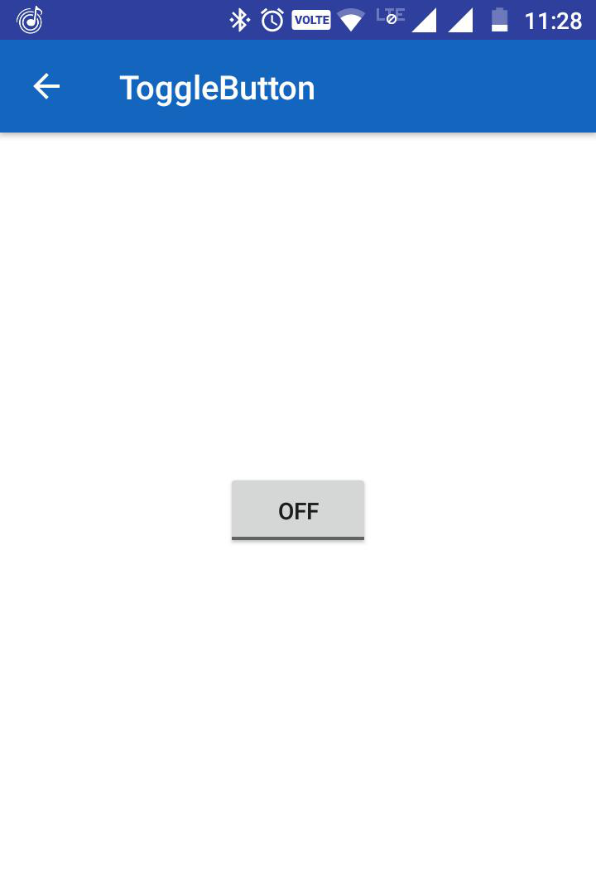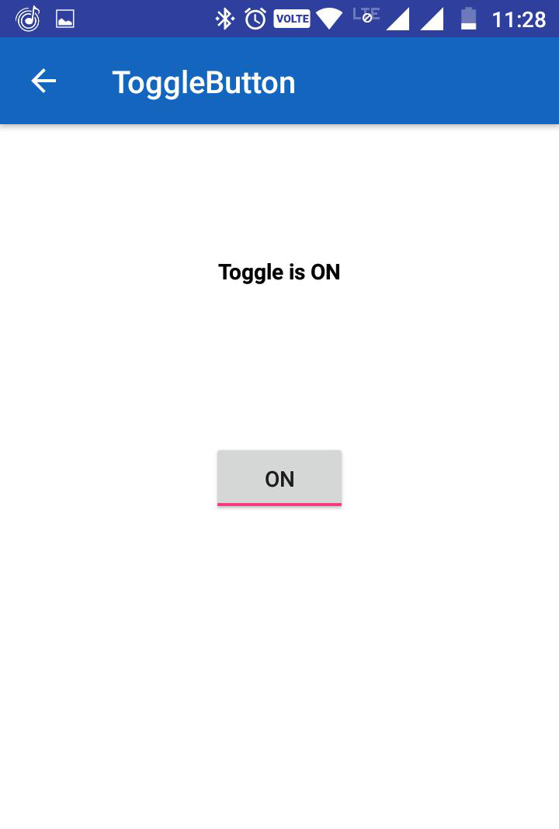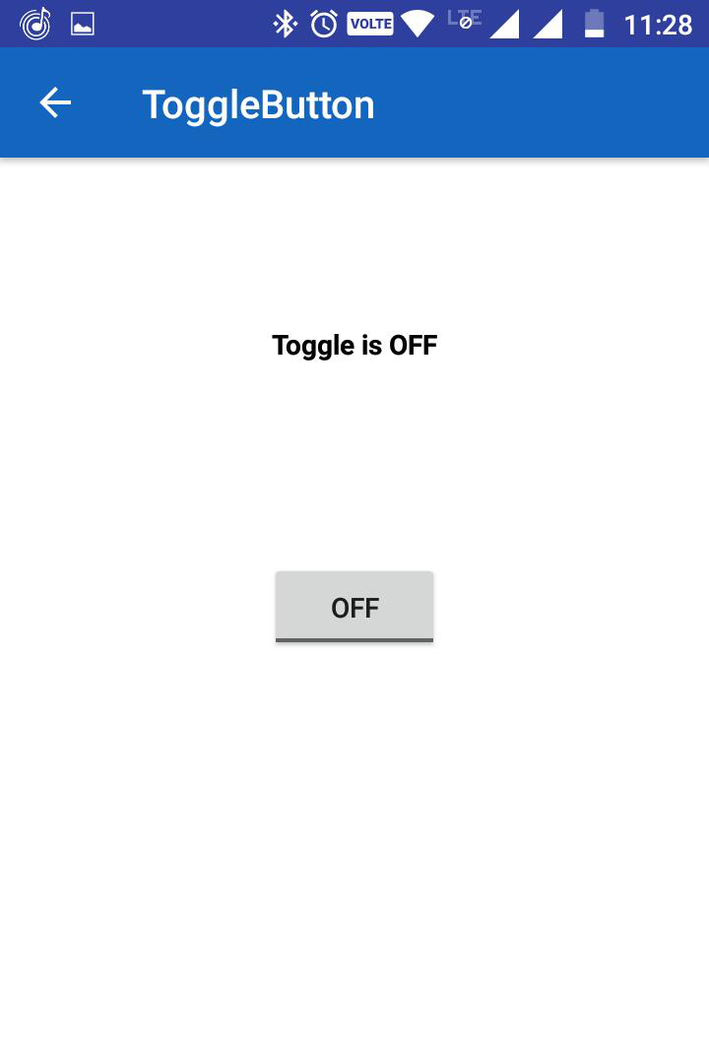

Practical no 3 : Toast Message

import android.support.v7.app.AppCompatActivity;

import android.os.Bundle;

import android.view.View;

import android.widget.Button;

import android.widget.Toast;

public class MainActivity extends AppCompatActivity {

// Defining the object for button

Button btn;

@Override

protected void onCreate(Bundle savedInstanceState) {

super.onCreate(savedInstanceState);

setContentView(R.layout.activity_main);

// Bind the components to their respective objects by assigning

// their IDs with the help of findViewById() method

Button btn = (Button)findViewById(R.id.Button01);

btn.setOnClickListener(new View.OnClickListener() {

@Override

public void onClick(View v) {

// Displaying simple Toast message

Toast.makeText(getApplicationContext(), "This a toast message", Toast.LENGTH_LONG).show();

}

});

}

}

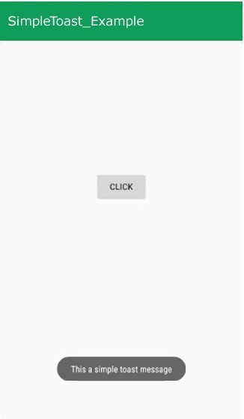

Practical 4

<?xml version="1.0" encoding="utf-8"?>  
<LinearLayout xmlns:android="http://schemas.android.com/apk/res/android"  
    android:orientation="vertical"  
    android:layout_width="match_parent"  
    android:layout_height="match_parent">  
    <CheckBox android:id="@+id/checkbox_meat"  
        android:layout_width="wrap_content"  
        android:layout_height="wrap_content"  
        android:text="Meat" />  
    <CheckBox android:id="@+id/checkbox_cheese"  
        android:layout_width="wrap_content"  
        android:layout_height="wrap_content"  
        android:text="Cheese"/>  
</LinearLayout>

findViewById<CheckBox>(R.id.checkbox_meat)  
    .setOnCheckedChangeListener { buttonView, isChecked ->  
        Log.d("CHECKBOXES", "Meat is checked: $isChecked");  
    }  
  
findViewById<CheckBox>(R.id.checkbox_cheese)  
    .setOnCheckedChangeListener { buttonView, isChecked ->  
        Log.d("CHECKBOXES", "Cheese is checked: $isChecked");  
    }

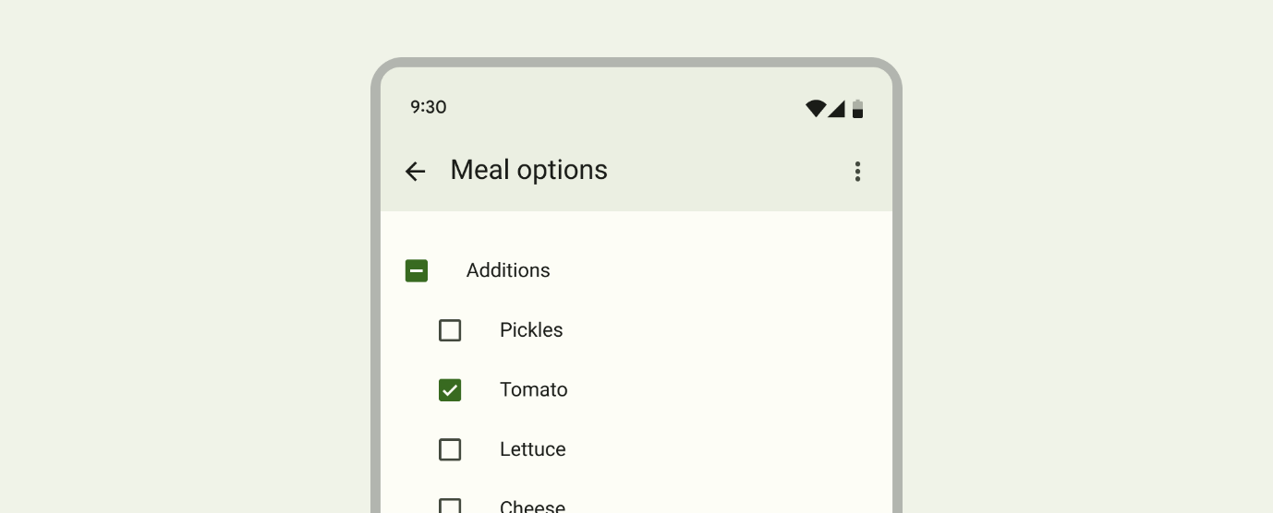

Alert Dialogue Box

import android.content.DialogInterface;

import android.os.Bundle;

import androidx.appcompat.app.AlertDialog;

import androidx.appcompat.app.AppCompatActivity;

public class MainActivity extends AppCompatActivity {

@Override

protected void onCreate(Bundle savedInstanceState) {

super.onCreate(savedInstanceState);

setContentView(R.layout.activity_main);

}

// Declare the onBackPressed method when the back button is pressed this method will call

@Override

public void onBackPressed() {

// Create the object of AlertDialog Builder class

AlertDialog.Builder builder = new AlertDialog.Builder(MainActivity.this);

// Set the message show for the Alert time

builder.setMessage("Do you want to exit ?");

// Set Alert Title

builder.setTitle("Alert !");

// Set Cancelable false for when the user clicks on the outside the Dialog Box then it will remain show

builder.setCancelable(false);

// Set the positive button with yes name Lambda OnClickListener method is use of DialogInterface interface.

builder.setPositiveButton("Yes", (DialogInterface.OnClickListener) (dialog, which) -> {

// When the user click yes button then app will close

finish();

});

// Set the Negative button with No name Lambda OnClickListener method is use of DialogInterface interface.

builder.setNegativeButton("No", (DialogInterface.OnClickListener) (dialog, which) -> {

// If user click no then dialog box is canceled.

dialog.cancel();

});

// Create the Alert dialog

AlertDialog alertDialog = builder.create();

// Show the Alert Dialog box

alertDialog.show();

}

}

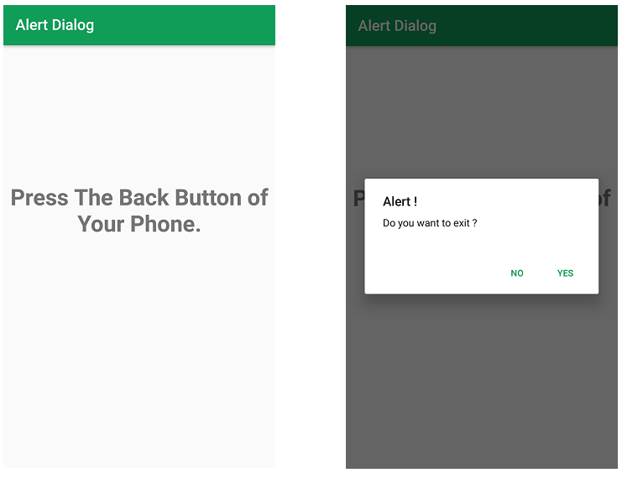

**Practical No 5 Spinner**

<?xml version="1.0" encoding="utf-8"?>

<!--Constraint layout which contain Spinner widget-->

<android.support.constraint.ConstraintLayout

xmlns:android="http://schemas.android.com/apk/res/android"

xmlns:app="http://schemas.android.com/apk/res-auto"

xmlns:tools="http://schemas.android.com/tools"

android:layout_width="match_parent"

android:layout_height="match_parent"

tools:context="com.geeksforgeeks.Spinner.MainActivity">

<!--Spinner widget-->

<Spinner

android:id="@+id/coursesspinner"

android:layout_height="50dp"

android:layout_width="160dp"

android:layout_marginEnd="10dp"

android:layout_marginStart="10dp"

android:layout_marginBottom="10dp"

android:layout_marginTop="10dp"

app:layout_constraintStart_toStartOf="parent"

app:layout_constraintTop_toTopOf="parent"/>

</android.support.constraint.ConstraintLayout>

import android.support.v7.app.AppCompatActivity;

import android.widget.AdapterView;

import android.view.View;

import android.os.Bundle;

import android.widget.ArrayAdapter;

import android.widget.Spinner;

import android.os.Bundle;

// Main Activity implements Adapter view

public class MainActivity

extends AppCompatActivity

implements AdapterView.OnItemSelectedListener {

// create array of Strings

// and store name of courses

String[] courses = { "C", "Data structures",

"Interview prep", "Algorithms",

"DSA with java", "OS" };

@Override

protected void onCreate(Bundle savedInstanceState)

{

super.onCreate(savedInstanceState);

setContentView(R.layout.activity_main);

// Take the instance of Spinner and

// apply OnItemSelectedListener on it which

// tells which item of spinner is clicked

Spinner spino = findViewById(R.id.coursesspinner);

spin.setOnItemSelectedListener(this);

// Create the instance of ArrayAdapter

// having the list of courses

ArrayAdapter ad

= new ArrayAdapter(

this,

android.R.layout.simple_spinner_item,

courses);

// set simple layout resource file

// for each item of spinner

ad.setDropDownViewResource(

android.R.layout

.simple_spinner_dropdown_item);

// Set the ArrayAdapter (ad) data on the

// Spinner which binds data to spinner

spino.setAdapter(ad);

}

// Performing action when ItemSelected

// from spinner, Overriding onItemSelected method

@Override

public void onItemSelected(AdapterView<*> arg0,

View arg1,

int position,

long id)

{

// make toastof name of course

// which is selected in spinner

Toast.makeText(getApplicationContext(),

courses[position],

Toast.LENGTH_LONG)

.show();

}

@Override

public void onNothingSelected(AdapterView<*> arg0)

{

// Auto-generated method stub

}

}

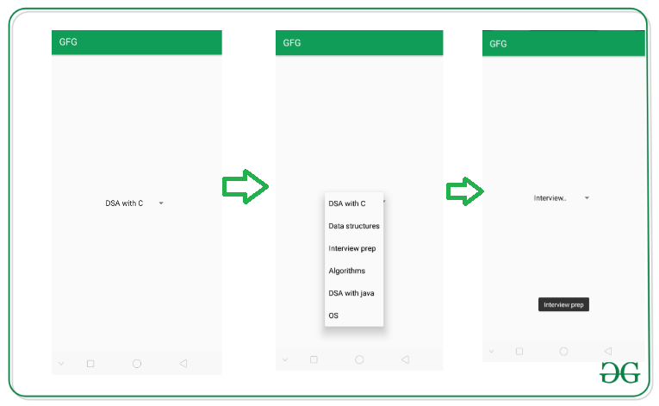

Auto Complete Text View

1. **<?xml** version="1.0" encoding="utf-8"**?>**
2. **<android.support.constraint.ConstraintLayout** xmlns:android="http://schemas.android.com/apk/res/android"
3. xmlns:app="http://schemas.android.com/apk/res-auto"
4. xmlns:tools="http://schemas.android.com/tools"
5. android:layout_width="match_parent"
6. android:layout_height="match_parent"
7. tools:context="example.javatpoint.com.autocompletetextview.MainActivity"**>**
9. **<TextView**
10. android:layout_width="wrap_content"
11. android:layout_height="wrap_content"
12. android:text="What is your favourite programming language?"
13. app:layout_constraintBottom_toBottomOf="parent"
14. app:layout_constraintLeft_toLeftOf="parent"
15. app:layout_constraintRight_toRightOf="parent"
16. app:layout_constraintTop_toTopOf="parent"
17. app:layout_constraintVertical_bias="0.032" **/>**
19. **<AutoCompleteTextView**
20. android:id="@+id/autoCompleteTextView"
21. android:layout_width="200dp"
22. android:layout_height="wrap_content"
23. android:layout_marginLeft="92dp"
24. android:layout_marginTop="144dp"
25. android:text=""
26. app:layout_constraintStart_toStartOf="parent"
27. app:layout_constraintTop_toTopOf="parent" **/>**
29. **</android.support.constraint.ConstraintLayout>**
30. **package** example.javatpoint.com.autocompletetextview;
32. **import** android.graphics.Color;
33. **import** android.support.v7.app.AppCompatActivity;
34. **import** android.os.Bundle;
35. **import** android.widget.ArrayAdapter;
36. **import** android.widget.AutoCompleteTextView;
38. **public** **class** MainActivity **extends** AppCompatActivity {
39. String[] language ={"C","C++","Java",".NET","iPhone","Android","ASP.NET","PHP"};
40. @Override
41. **protected** **void** onCreate(Bundle savedInstanceState) {
42. **super**.onCreate(savedInstanceState);
43. setContentView(R.layout.activity_main);
44. //Creating the instance of ArrayAdapter containing list of language names
45. ArrayAdapter<String> adapter = **new** ArrayAdapter<String>
46. (**this**,android.R.layout.select_dialog_item,language);
47. //Getting the instance of AutoCompleteTextView
48. AutoCompleteTextView actv =  (AutoCompleteTextView)findViewById(R.id.autoCompleteTextView);
49. actv.setThreshold(1);//will start working from first character
50. actv.setAdapter(adapter);//setting the adapter data into the AutoCompleteTextView
51. actv.setTextColor(Color.RED);
52. }
53. }

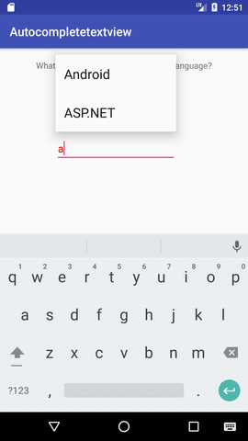 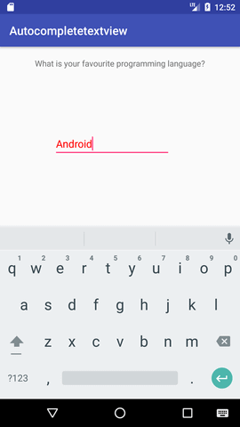

**Practical No 6 Calculator in android**

**<TableLayout** xmlns:android="http://schemas.android.com/apk/res/android"

xmlns:tools="http://schemas.android.com/tools"

android:layout_width="match_parent"

android:layout_height="match_parent"

android:columnCount="2"

android:paddingBottom="@dimen/activity_vertical_margin"

android:paddingLeft="@dimen/activity_horizontal_margin"

android:paddingRight="@dimen/activity_horizontal_margin"

android:paddingTop="@dimen/activity_vertical_margin"

tools:context=".MainActivity" **>**

**<EditText**

android:id="@+id/textView1"

android:layout_width="match_parent"

android:layout_height="wrap_content"

android:text="0"

android:textSize="30sp" **/>**

**<TextView**

android:id="@+id/textView2"

android:layout_width="match_parent"

android:layout_height="wrap_content"

android:text="TextView"

android:textSize="30sp" **/>**

**<RelativeLayout**

android:layout_width="match_parent"

android:layout_height="wrap_content"

android:layout_marginTop="40dp"

android:layout_weight="0.29" **>**

**<Button**

android:id="@+id/add"

android:layout_width="80dp"

android:layout_height="wrap_content"

android:text="+"

android:textSize="20dp" **>**

**</Button>**

**<Button**

android:id="@+id/sub"

android:layout_width="80dp"

android:layout_height="wrap_content"

android:layout_alignBaseline="@+id/button1"

android:layout_alignBottom="@+id/button1"

android:layout_centerHorizontal="true"

android:text="-" **/>**

**<Button**

android:id="@+id/mul"

android:layout_width="80dp"

android:layout_height="wrap_content"

android:layout_alignBaseline="@+id/button2"

android:layout_alignBottom="@+id/button2"

android:layout_alignParentRight="true"

android:text="X" **/>**

**<Button**

android:id="@+id/calculate"

android:layout_width="match_parent"

android:layout_height="wrap_content"

android:layout_alignParentBottom="true"

android:layout_alignParentRight="true"

android:layout_marginBottom="64dp"

android:textAlignment="center"

android:text="Calculate" **/>**

**<Button**

android:id="@+id/color"

android:layout_width="match_parent"

android:layout_height="wrap_content"

android:layout_alignParentBottom="true"

android:layout_alignParentRight="true"

android:text="ChangeColor"

android:textAlignment="center"**/>**

**<Button**

android:id="@+id/divide"

android:layout_width="80dp"

android:layout_height="wrap_content"

android:layout_alignParentLeft="true"

android:layout_below="@+id/add"

android:layout_marginTop="47dp"

android:text="/" **/>**

**<Button**

android:id="@+id/log"

android:layout_width="80dp"

android:layout_height="wrap_content"

android:layout_alignBaseline="@+id/divide"

android:layout_alignBottom="@+id/divide"

android:layout_alignLeft="@+id/sub"

android:text="log" **/>**

**<Button**

android:id="@+id/clear"

android:layout_width="80dp"

android:layout_height="wrap_content"

android:layout_alignBaseline="@+id/log"

android:layout_alignBottom="@+id/log"

android:layout_alignParentRight="true"

android:text="C" **/>**

**</RelativeLayout>**

**</TableLayout>**

**package** com.example.calculator;

**import** android.R.color;

**import** android.os.Bundle;

**import** android.app.Activity;

**import** android.view.Menu;

**import** android.view.View;

**import** android.view.View.OnClickListener;

**import** android.widget.Button;

**import** android.widget.TextView;

**import** android.widget.Toast;

**public** **class** MainActivity **extends** Activity **implements** OnClickListener {

TextView disp, res;

@Override

**protected** **void** onCreate(Bundle savedInstanceState) {

**super**.onCreate(savedInstanceState);

setContentView(R.layout.activity_main);

disp = (TextView) findViewById(R.id.textView1);

res = (TextView) findViewById(R.id.textView2);

Button add = (Button) findViewById(R.id.add);

Button mul = (Button) findViewById(R.id.mul);

Button divide = (Button) findViewById(R.id.divide);

Button sub = (Button) findViewById(R.id.sub);

Button log = (Button) findViewById(R.id.log);

Button clear = (Button) findViewById(R.id.clear);

Button calc = (Button) findViewById(R.id.calculate);

Button change = (Button) findViewById(R.id.color);

add.setOnClickListener(**this**);

mul.setOnClickListener(**this**);

divide.setOnClickListener(**this**);

sub.setOnClickListener(**this**);

log.setOnClickListener(**this**);

clear.setOnClickListener(**this**);

calc.setOnClickListener(**this**);

change.setOnClickListener(**this**);

}

@Override

**public** **boolean** onCreateOptionsMenu(Menu menu) {

*// Inflate the menu; this adds items to the action bar if it is present.*

getMenuInflater().inflate(R.menu.main, menu);

**return** **true**;

}

@Override

**public** **void** onClick(View v) {

*// TODO Auto-generated method stub*

**float** result = 0, num1, num2;

Toast var;

**switch** (v.getId()) {

**case** R.id.add:

String str =(String) disp.getText();

num1 = Integer.parseInt(str);

disp.setText("");

var = Toast.makeText(MainActivity.**this**, "Enter other number",

Toast.LENGTH_SHORT);

var.show();

str=(String) disp.getText();

num2 = Integer.parseInt(str);

result = num1 + num2;

**break**;

**case** R.id.sub:

num1 = Integer.parseInt((String) disp.getText());

disp.setText("");

var = Toast.makeText(MainActivity.**this**, "Enter other number",

Toast.LENGTH_SHORT);

var.show();

num2 = Integer.parseInt((String) disp.getText());

result = num1 - num2;

**break**;

**case** R.id.mul:

num1 = Integer.parseInt((String) disp.getText());

disp.setText("");

var = Toast.makeText(MainActivity.**this**, "Enter other number",

Toast.LENGTH_SHORT);

var.show();

num2 = Integer.parseInt((String) disp.getText());

result = num1 * num2;

**break**;

**case** R.id.divide:

num1 = Integer.parseInt((String) disp.getText());

disp.setText("");

var = Toast.makeText(MainActivity.**this**, "Enter other number",

Toast.LENGTH_SHORT);

var.show();

num2 = Integer.parseInt((String) disp.getText());

result = num1 / num2;

**break**;

**case** R.id.log:

num1 = Integer.parseInt((String) disp.getText());

result = (**float**) Math.log(num1);

**break**;

**case** R.id.clear:

disp.setText("");

res.setText("");

**break**;

**case** R.id.color:

**int** rand = (**int**) ((Math.random() * 10) % 3);

Button b1 = (Button) findViewById(R.id.add);

Button b2 = (Button) findViewById(R.id.mul);

Button b3 = (Button) findViewById(R.id.divide);

Button b4 = (Button) findViewById(R.id.sub);

Button b5 = (Button) findViewById(R.id.log);

Button b6 = (Button) findViewById(R.id.clear);

Button b7 = (Button) findViewById(R.id.calculate);

Button b8 = (Button) findViewById(R.id.color);

rand =2;

**switch** (rand) {

**case** 0:

b1.setTextColor(color.holo_blue_bright);

b2.setTextColor(color.holo_blue_bright);

b3.setTextColor(color.holo_blue_bright);

b4.setTextColor(color.holo_blue_bright);

b5.setTextColor(color.holo_blue_bright);

b6.setTextColor(color.holo_blue_bright);

b7.setTextColor(color.holo_blue_bright);

b8.setTextColor(color.holo_blue_bright);

**break**;

**case** 1:

b1.setTextColor(color.holo_green_dark);

b2.setTextColor(color.holo_green_dark);

b3.setTextColor(color.holo_green_dark);

b4.setTextColor(color.holo_green_dark);

b5.setTextColor(color.holo_green_dark);

b6.setTextColor(color.holo_green_dark);

b7.setTextColor(color.holo_green_dark);

b8.setTextColor(color.holo_green_dark);

**break**;

**case** 2:

b1.setTextColor(color.holo_red_dark);

b2.setTextColor(color.holo_red_dark);

b3.setTextColor(color.holo_red_dark);

b4.setTextColor(color.holo_red_dark);

b5.setTextColor(color.holo_red_dark);

b6.setTextColor(color.holo_red_dark);

b7.setTextColor(color.holo_red_dark);

b8.setTextColor(color.holo_red_dark);

**break**;

**default**:

b1.setTextColor(color.black);

b2.setTextColor(color.black);

b3.setTextColor(color.black);

b4.setTextColor(color.black);

b5.setTextColor(color.black);

b6.setTextColor(color.black);

b7.setTextColor(color.black);

b8.setTextColor(color.black);

**break**;

}

**break**;

**case** R.id.calculate:

res.setText(Float.toString(result));

**break**;

}

}

}

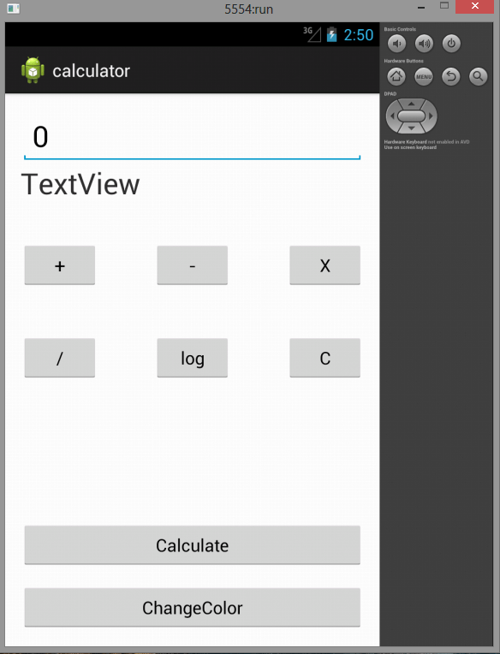

**Practical No 7 Rating Bar In Android**

1. **<?xml** version="1.0" encoding="utf-8"**?>**
2. **<android.support.constraint.ConstraintLayout** xmlns:android="http://schemas.android.com/apk/res/android"
3. xmlns:app="http://schemas.android.com/apk/res-auto"
4. xmlns:tools="http://schemas.android.com/tools"
5. android:layout_width="match_parent"
6. android:layout_height="match_parent"
7. tools:context="example.javatpoint.com.ratingbar.MainActivity"**>**
9. **<Button**
10. android:layout_width="wrap_content"
11. android:layout_height="wrap_content"
12. android:text="submit"
13. android:id="@+id/button"
14. app:layout_constraintBottom_toBottomOf="parent"
15. app:layout_constraintLeft_toLeftOf="parent"
16. app:layout_constraintRight_toRightOf="parent"
17. app:layout_constraintTop_toTopOf="parent"
18. app:layout_constraintVertical_bias="0.615" **/>**
20. **<RatingBar**
21. android:id="@+id/ratingBar"
22. android:layout_width="wrap_content"
23. android:layout_height="wrap_content"
24. android:layout_marginLeft="72dp"
25. android:layout_marginTop="60dp"
26. app:layout_constraintStart_toStartOf="parent"
27. app:layout_constraintTop_toTopOf="parent" **/>**
29. **</android.support.constraint.ConstraintLayout>**
30. **package** example.javatpoint.com.ratingbar;
32. **import** android.support.v7.app.AppCompatActivity;
33. **import** android.os.Bundle;
34. **import** android.view.View;
35. **import** android.widget.Button;
36. **import** android.widget.RatingBar;
37. **import** android.widget.Toast;
39. **public** **class** MainActivity **extends** AppCompatActivity {
40. RatingBar ratingbar;
41. Button button;
42. @Override
43. **protected** **void** onCreate(Bundle savedInstanceState) {
44. **super**.onCreate(savedInstanceState);
45. setContentView(R.layout.activity_main);
46. addListenerOnButtonClick();
47. }
48. **public** **void** addListenerOnButtonClick(){
49. ratingbar=(RatingBar)findViewById(R.id.ratingBar);
50. button=(Button)findViewById(R.id.button);
51. //Performing action on Button Click
52. button.setOnClickListener(**new** View.OnClickListener(){
54. @Override
55. **public** **void** onClick(View arg0) {
56. //Getting the rating and displaying it on the toast
57. String rating=String.valueOf(ratingbar.getRating());
58. Toast.makeText(getApplicationContext(), rating, Toast.LENGTH_LONG).show();
59. }
61. });
62. }
63. }

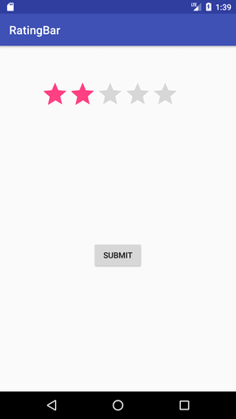 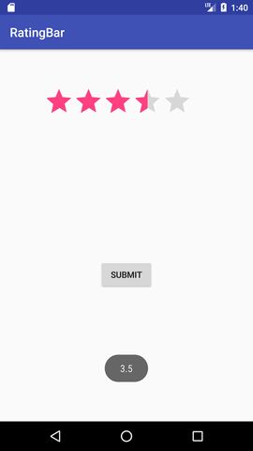

Web View

<?xml version="1.0" encoding="utf-8"?>

<RelativeLayout xmlns:android="http://schemas.android.com/apk/res/android"

xmlns:tools="http://schemas.android.com/tools"

android:layout_width="match_parent"

android:layout_height="match_parent"

tools:context="com.gfg.android.examplekotlin.MainActivity">

<!-- unique ID of WebView -->

<WebView

android:id="@+id/web"

android:layout_width="match_parent"

android:layout_height="match_parent"

tools:layout_editor_absoluteX="8dp"

tools:layout_editor_absoluteY="8dp" />

</RelativeLayout>

import android.os.Bundle;

import android.webkit.WebView;

import android.webkit.WebViewClient;

import androidx.appcompat.app.AppCompatActivity;

public class MainActivity extends AppCompatActivity {

@Override

protected void onCreate(Bundle savedInstanceState) {

super.onCreate(savedInstanceState);

setContentView(R.layout.activity_main);

// Find the WebView by its unique ID

WebView webView = findViewById(R.id.web);

// loading https://www.geeksforgeeks.org url in the WebView.

webView.loadUrl("https://www.geeksforgeeks.org");

// this will enable the javascript.

webView.getSettings().setJavaScriptEnabled(true);

// WebViewClient allows you to handle

// onPageFinished and override Url loading.

webView.setWebViewClient(new WebViewClient());

}

}

**Seek bar**

1. **<?xml** version="1.0" encoding="utf-8"**?>**
2. **<android.support.constraint.ConstraintLayout** xmlns:android="http://schemas.android.com/apk/res/android"
3. xmlns:app="http://schemas.android.com/apk/res-auto"
4. xmlns:tools="http://schemas.android.com/tools"
5. android:layout_width="match_parent"
6. android:layout_height="match_parent"
7. tools:context="example.javatpoint.com.seekbar.MainActivity"**>**

10. **<SeekBar**
11. android:id="@+id/seekBar"
12. android:layout_width="match_parent"
13. android:layout_height="wrap_content"
14. android:layout_marginEnd="8dp"
15. android:layout_marginStart="8dp"
16. android:layout_marginTop="372dp"
17. app:layout_constraintEnd_toEndOf="parent"
18. app:layout_constraintStart_toStartOf="parent"
19. app:layout_constraintTop_toTopOf="parent" **/>**
20. **</android.support.constraint.ConstraintLayout>**
21. **package** example.javatpoint.com.seekbar;
23. **import** android.support.v7.app.AppCompatActivity;
24. **import** android.os.Bundle;
25. **import** android.widget.SeekBar;
26. **import** android.widget.Toast;
28. **public** **class** MainActivity **extends** AppCompatActivity {
29. SeekBar seekBar;
30. @Override
31. **protected** **void** onCreate(Bundle savedInstanceState) {
32. **super**.onCreate(savedInstanceState);
33. setContentView(R.layout.activity_main);
35. seekBar=(SeekBar)findViewById(R.id.seekBar);
36. seekBar.setOnSeekBarChangeListener(**new** SeekBar.OnSeekBarChangeListener() {
37. @Override
38. **public** **void** onProgressChanged(SeekBar seekBar, **int** progress,
39. **boolean** fromUser) {
40. Toast.makeText(getApplicationContext(),"seekbar progress: "+progress, Toast.LENGTH_SHORT).show();
41. }
43. @Override
44. **public** **void** onStartTrackingTouch(SeekBar seekBar) {
45. Toast.makeText(getApplicationContext(),"seekbar touch started!", Toast.LENGTH_SHORT).show();
46. }
48. @Override
49. **public** **void** onStopTrackingTouch(SeekBar seekBar) {
50. Toast.makeText(getApplicationContext(),"seekbar touch stopped!", Toast.LENGTH_SHORT).show();
51. }
52. });
53. }
54. }

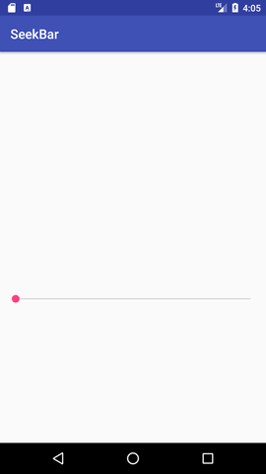 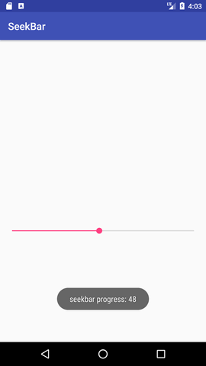

***Practical No 8 Registration Form***

<?xml version="1.0" encoding="utf-8"?>  
<LinearLayout xmlns:android="http://schemas.android.com/apk/res/android"  
    android:orientation="vertical" android:layout_width="match_parent"  
    android:layout_height="match_parent">  
    <TextView  
        android:id="@+id/loginscrn"  
        android:layout_width="wrap_content"  
        android:layout_height="wrap_content"  
        android:layout_marginTop="80dp"  
        android:text="Login"  
        android:textSize="25dp"  
        android:textStyle="bold"  
        android:layout_gravity="center"/>  
    <TextView  
        android:id="@+id/fstTxt"  
        android:layout_width="wrap_content"  
        android:layout_height="wrap_content"  
        android:layout_marginLeft="100dp"  
        android:layout_marginTop="20dp"  
        android:text="Email"/>  
    <EditText  
        android:id="@+id/txtEmail"  
        android:layout_width="wrap_content"  
        android:layout_height="wrap_content"  
        android:layout_marginLeft="100dp"  
        android:ems="10"/>  
    <TextView  
        android:id="@+id/secTxt"  
        android:layout_width="wrap_content"  
        android:layout_height="wrap_content"  
        android:text="Password"  
        android:layout_marginLeft="100dp" />  
    <EditText  
        android:id="@+id/txtPwd"  
        android:layout_width="wrap_content"  
        android:layout_height="wrap_content"  
        android:layout_marginLeft="100dp"  
        android:inputType="textPassword"  
        android:ems="10" />  
    <Button  
        android:id="@+id/btnLogin"  
        android:layout_width="wrap_content"  
        android:layout_height="wrap_content"  
        android:layout_marginLeft="100dp"  
        android:text="Login" />  
    <TextView android:id="@+id/lnkRegister"  
        android:layout_width="match_parent"  
        android:layout_height="wrap_content"  
        android:layout_marginTop="40dp"  
        android:text="New to Tutlane? Register here"  
        android:gravity="center"  
        android:textSize="20dp"  
        android:textColor="#3F51B5"/>  
</LinearLayout>

<?xml version="1.0" encoding="utf-8"?>  
<LinearLayout xmlns:android="http://schemas.android.com/apk/res/android"  
    android:orientation="vertical" android:layout_width="match_parent"  
    android:layout_height="match_parent">  
    <TextView  
        android:id="@+id/loginscrn"  
        android:layout_width="wrap_content"  
        android:layout_height="wrap_content"  
        android:layout_marginTop="80dp"  
        android:text="Registration"  
        android:textSize="25dp"  
        android:textStyle="bold"  
        android:layout_gravity="center"/>  
    <TextView  
        android:id="@+id/fstTxt"  
        android:layout_width="wrap_content"  
        android:layout_height="wrap_content"  
        android:layout_marginLeft="100dp"  
        android:layout_marginTop="20dp"  
        android:text="Full Name"/>  
    <EditText  
        android:id="@+id/txtName"  
        android:layout_width="wrap_content"  
        android:layout_height="wrap_content"  
        android:layout_marginLeft="100dp"  
        android:ems="10"/>  
    <TextView  
        android:id="@+id/secTxt"  
        android:layout_width="wrap_content"  
        android:layout_height="wrap_content"  
        android:text="Email"  
        android:layout_marginLeft="100dp" />  
    <EditText  
        android:id="@+id/txtEmail"  
        android:layout_width="wrap_content"  
        android:layout_height="wrap_content"  
        android:layout_marginLeft="100dp"  
        android:ems="10" />  
    <TextView  
        android:id="@+id/thirdTxt"  
        android:layout_width="wrap_content"  
        android:layout_height="wrap_content"  
        android:text="Password"  
        android:layout_marginLeft="100dp" />  
    <EditText  
        android:id="@+id/txtPwd"  
        android:layout_width="wrap_content"  
        android:layout_height="wrap_content"  
        android:layout_marginLeft="100dp"  
        android:inputType="textPassword"  
        android:ems="10" />  
    <Button  
        android:id="@+id/btnLogin"  
        android:layout_width="wrap_content"  
        android:layout_height="wrap_content"  
        android:layout_marginLeft="100dp"  
        android:text="Login" />  
    <TextView android:id="@+id/lnkLogin"  
        android:layout_width="match_parent"  
        android:layout_height="wrap_content"  
        android:layout_marginTop="40dp"  
        android:text="Already Registered? Login here"  
        android:gravity="center"  
        android:textSize="20dp"  
        android:textColor="#3F51B5"  
        android:onClick="test"/>  
</LinearLayout>

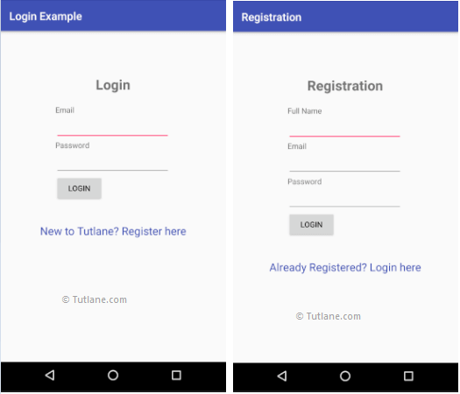

**Practical no 9 Date Picker**

1. **<?xml** version="1.0" encoding="utf-8"**?>**
2. **<RelativeLayout** xmlns:android="http://schemas.android.com/apk/res/android"
3. xmlns:app="http://schemas.android.com/apk/res-auto"
4. xmlns:tools="http://schemas.android.com/tools"
5. android:layout_width="match_parent"
6. android:layout_height="match_parent"
7. tools:context="example.javatpoint.com.datepicker.MainActivity"**>**
9. **<TextView**
10. android:id="@+id/textView1"
11. android:layout_width="wrap_content"
12. android:layout_height="wrap_content"
13. android:layout_above="@+id/button1"
14. android:layout_alignParentLeft="true"
15. android:layout_alignParentStart="true"
16. android:layout_marginBottom="102dp"
17. android:layout_marginLeft="30dp"
18. android:layout_marginStart="30dp"
19. android:text="" **/>**
21. **<Button**
22. android:id="@+id/button1"
23. android:layout_width="wrap_content"
24. android:layout_height="wrap_content"
25. android:layout_alignParentBottom="true"
26. android:layout_centerHorizontal="true"
27. android:layout_marginBottom="20dp"
28. android:text="Change Date" **/>**
30. **<DatePicker**
31. android:id="@+id/datePicker"
32. android:layout_width="wrap_content"
33. android:layout_height="wrap_content"
34. android:layout_above="@+id/textView1"
35. android:layout_centerHorizontal="true"
36. android:layout_marginBottom="36dp" **/>**
38. **</RelativeLayout>**
39. **package** example.javatpoint.com.datepicker;
41. **import** android.support.v7.app.AppCompatActivity;
42. **import** android.os.Bundle;
43. **import** android.view.View;
44. **import** android.widget.Button;
45. **import** android.widget.DatePicker;
46. **import** android.widget.TextView;
48. **public** **class** MainActivity **extends** AppCompatActivity {
49. DatePicker picker;
50. Button displayDate;
51. TextView textview1;
52. @Override
53. **protected** **void** onCreate(Bundle savedInstanceState) {
54. **super**.onCreate(savedInstanceState);
55. setContentView(R.layout.activity_main);
57. textview1=(TextView)findViewById(R.id.textView1);
58. picker=(DatePicker)findViewById(R.id.datePicker);
59. displayDate=(Button)findViewById(R.id.button1);
61. textview1.setText("Current Date: "+getCurrentDate());
63. displayDate.setOnClickListener(**new** View.OnClickListener(){
64. @Override
65. **public** **void** onClick(View view) {
67. textview1.setText("Change Date: "+getCurrentDate());
68. }
70. });
72. }
73. **public** String getCurrentDate(){
74. StringBuilder builder=**new** StringBuilder();;
75. builder.append((picker.getMonth() + 1)+"/");//month is 0 based
76. builder.append(picker.getDayOfMonth()+"/");
77. builder.append(picker.getYear());
78. **return** builder.toString();
79. }
80. }

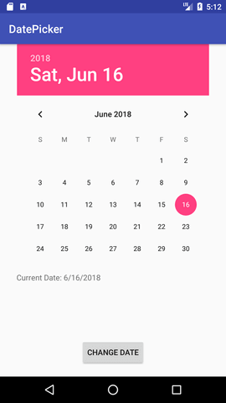 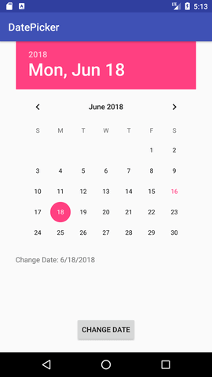

Time Picker

activity_main.xml

*File: activity_main.xml*

1. **<?xml** version="1.0" encoding="utf-8"**?>**
2. **<RelativeLayout** xmlns:android="http://schemas.android.com/apk/res/android"
3. xmlns:app="http://schemas.android.com/apk/res-auto"
4. xmlns:tools="http://schemas.android.com/tools"
5. android:layout_width="match_parent"
6. android:layout_height="match_parent"
7. tools:context="example.javatpoint.com.timepicker.MainActivity"**>**
9. **<TextView**
10. android:id="@+id/textView1"
11. android:layout_width="wrap_content"
12. android:layout_height="wrap_content"
13. android:layout_above="@+id/button1"
14. android:layout_alignParentLeft="true"
15. android:layout_alignParentStart="true"
16. android:layout_marginBottom="102dp"
17. android:layout_marginLeft="30dp"
18. android:layout_marginStart="30dp"
19. android:text="" **/>**
21. **<Button**
22. android:id="@+id/button1"
23. android:layout_width="wrap_content"
24. android:layout_height="wrap_content"
25. android:layout_alignParentBottom="true"
26. android:layout_centerHorizontal="true"
27. android:layout_marginBottom="20dp"
28. android:text="Change Time" **/>**
30. **<TimePicker**
31. android:id="@+id/timePicker"
32. android:layout_width="wrap_content"
33. android:layout_height="wrap_content"
34. android:layout_above="@+id/textView1"
35. android:layout_centerHorizontal="true"
36. android:layout_marginBottom="36dp" **/>**
37. **</RelativeLayout>**

Activity class

*File: MainActivity.java*

1. **package** example.javatpoint.com.timepicker;
3. **import** android.support.v7.app.AppCompatActivity;
4. **import** android.os.Bundle;
5. **import** android.view.View;
6. **import** android.widget.Button;
7. **import** android.widget.TextView;
8. **import** android.widget.TimePicker;
10. **public** **class** MainActivity **extends** AppCompatActivity {
11. TextView textview1;
12. TimePicker timepicker;
13. Button changetime;
14. @Override
15. **protected** **void** onCreate(Bundle savedInstanceState) {
16. **super**.onCreate(savedInstanceState);
17. setContentView(R.layout.activity_main);
19. textview1=(TextView)findViewById(R.id.textView1);
20. timepicker=(TimePicker)findViewById(R.id.timePicker);
21. //Uncomment the below line of code for 24 hour view
22. timepicker.setIs24HourView(**true**);
23. changetime=(Button)findViewById(R.id.button1);
25. textview1.setText(getCurrentTime());
27. changetime.setOnClickListener(**new** View.OnClickListener(){
28. @Override
29. **public** **void** onClick(View view) {
30. textview1.setText(getCurrentTime());
31. }
32. });
34. }
36. **public** String getCurrentTime(){
37. String currentTime="Current Time: "+timepicker.getCurrentHour()+":"+timepicker.getCurrentMinute();
38. **return** currentTime;
39. }
41. }

Output:

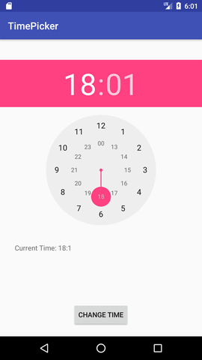 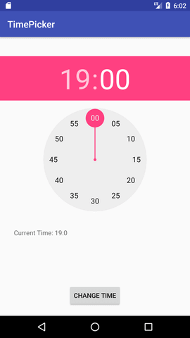

Progress bar

## **Practical no 10 Android Progress Bar Example by ProgressDialog**

Let's see a simple example to create progress bar using ProgressDialog class.

#### activity_main.xml

Drag one button from the pallete, now the activity_main.xml file will look like this:

*File: activity_main.xml*

1. **<RelativeLayout** xmlns:androclass="http://schemas.android.com/apk/res/android"
2. xmlns:tools="http://schemas.android.com/tools"
3. android:layout_width="match_parent"
4. android:layout_height="match_parent"
5. tools:context=".MainActivity" **>**
7. **<Button**
8. android:id="@+id/button1"
9. android:layout_width="wrap_content"
10. android:layout_height="wrap_content"
11. android:layout_alignParentTop="true"
12. android:layout_centerHorizontal="true"
13. android:layout_marginTop="116dp"
14. android:text="download file" **/>**
16. **</RelativeLayout>**

#### Activity class

Let's write the code to display the progress bar dialog box.

*File: MainActivity.java*

1. **package** example.javatpoint.com.progressbar;
3. **import** android.app.ProgressDialog;
4. **import** android.os.Handler;
5. **import** android.support.v7.app.AppCompatActivity;
6. **import** android.os.Bundle;
7. **import** android.view.View;
8. **import** android.widget.Button;
10. **public** **class** MainActivity **extends** AppCompatActivity {
11. Button btnStartProgress;
12. ProgressDialog progressBar;
13. **private** **int** progressBarStatus = 0;
14. **private** Handler progressBarHandler = **new** Handler();
15. **private** **long** fileSize = 0;
16. @Override
17. **protected** **void** onCreate(Bundle savedInstanceState) {
18. **super**.onCreate(savedInstanceState);
19. setContentView(R.layout.activity_main);
20. addListenerOnButtonClick();
21. }
22. **public** **void** addListenerOnButtonClick() {
23. btnStartProgress = findViewById(R.id.button);
24. btnStartProgress.setOnClickListener(**new** View.OnClickListener(){
26. @Override
27. **public** **void** onClick(View v) {
28. // creating progress bar dialog
29. progressBar = **new** ProgressDialog(v.getContext());
30. progressBar.setCancelable(**true**);
31. progressBar.setMessage("File downloading ...");
32. progressBar.setProgressStyle(ProgressDialog.STYLE_HORIZONTAL);
33. progressBar.setProgress(0);
34. progressBar.setMax(100);
35. progressBar.show();
36. //reset progress bar and filesize status
37. progressBarStatus = 0;
38. fileSize = 0;
40. **new** Thread(**new** Runnable() {
41. **public** **void** run() {
42. **while** (progressBarStatus < 100) {
43. // performing operation
44. progressBarStatus = doOperation();
45. **try** {
46. Thread.sleep(1000);
47. } **catch** (InterruptedException e) {
48. e.printStackTrace();
49. }
50. // Updating the progress bar
51. progressBarHandler.post(**new** Runnable() {
52. **public** **void** run() {
53. progressBar.setProgress(progressBarStatus);
54. }
55. });
56. }
57. // performing operation if file is downloaded,
58. **if** (progressBarStatus >= 100) {
59. // sleeping for 1 second after operation completed
60. **try** {
61. Thread.sleep(1000);
62. } **catch** (InterruptedException e) {
63. e.printStackTrace();
64. }
65. // close the progress bar dialog
66. progressBar.dismiss();
67. }
68. }
69. }).start();
70. }//end of onClick method
71. });
72. }
73. // checking how much file is downloaded and updating the filesize
74. **public** **int** doOperation() {
75. //The range of ProgressDialog starts from 0 to 10000
76. **while** (fileSize <= 10000) {
77. fileSize++;
78. **if** (fileSize == 1000) {
79. **return** 10;
80. } **else** **if** (fileSize == 2000) {
81. **return** 20;
82. } **else** **if** (fileSize == 3000) {
83. **return** 30;
84. } **else** **if** (fileSize == 4000) {
85. **return** 40; // you can add more else if
86. }
87. /* else {
88. return 100;
89. }*/
90. }//end of while
91. **return** 100;
92. }//end of doOperation
93. }

#### Output:

